Create a Free Tier AWS Account

**Steps to Creating a Free tier AWS Account**

**Step 1: Sign Up for an AWS Account**

* Open AWS Sign-up Page in any browser.
* Enter your email address and AWS account name.
* Click “Verify Email Address” and enter the verification code received in your email.

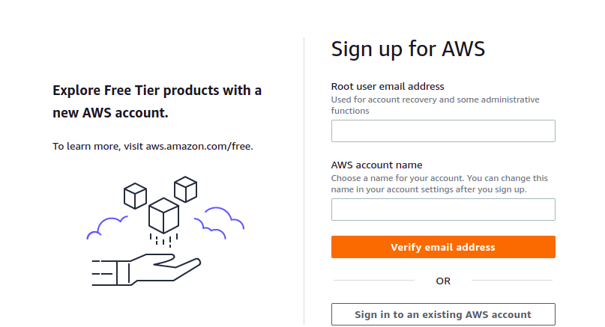

**Step 2: Set Root User Password**

* Enter and confirm the Root user password.
* Click “Continue (step 1 of 5)”.

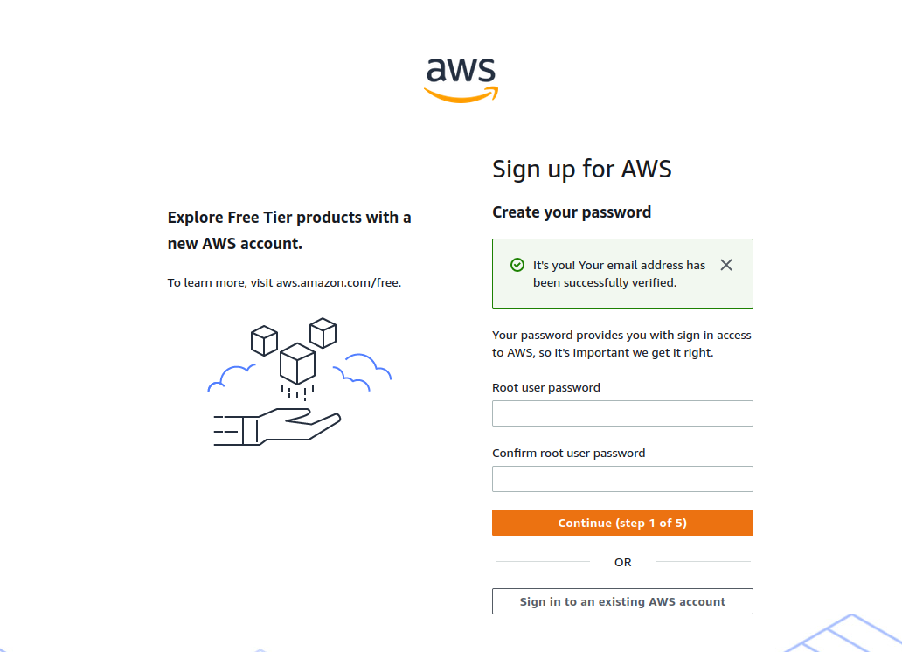

**Step 3: Account Type Selection**

* Choose “Personal – for your own projects”.
* Fill in personal details like full name, contact number, country, and address.
* Click “Continue (Step 2 of 5)”.

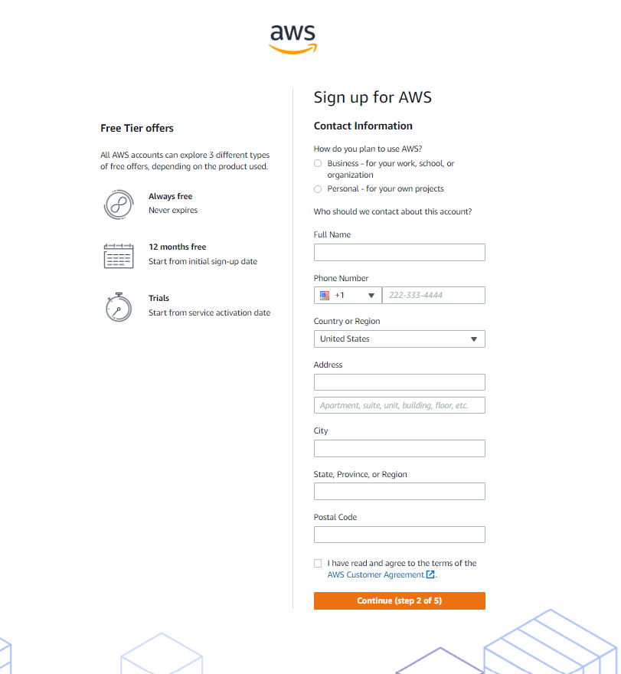

**Step 4: Billing Information**

* Enter billing details.
* Click “Verify and Continue”.

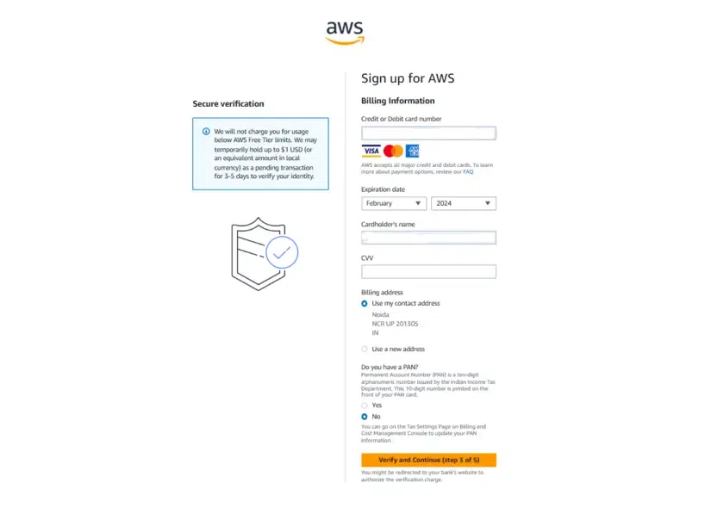

**Step 5: Identity Verification**

* Confirm identity via mobile number or email.
* Enter verification code.
* Click “Continue”.

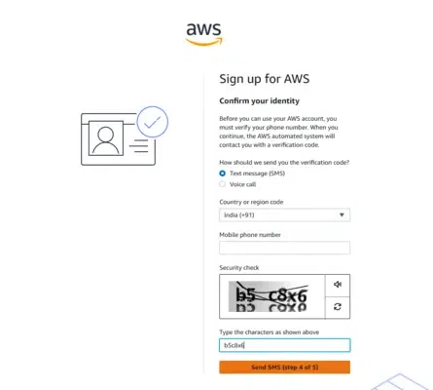

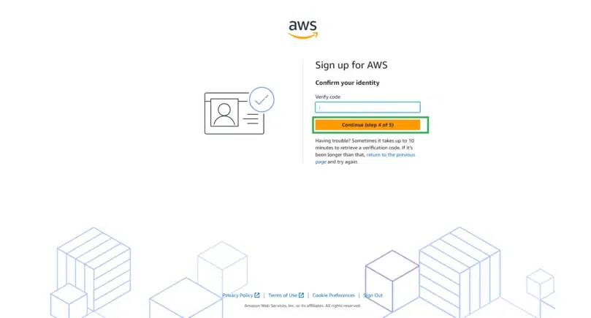

**Step 6: Select Support Plan**

* Choose “Basic Support – Free”.
* Click “Continue”.

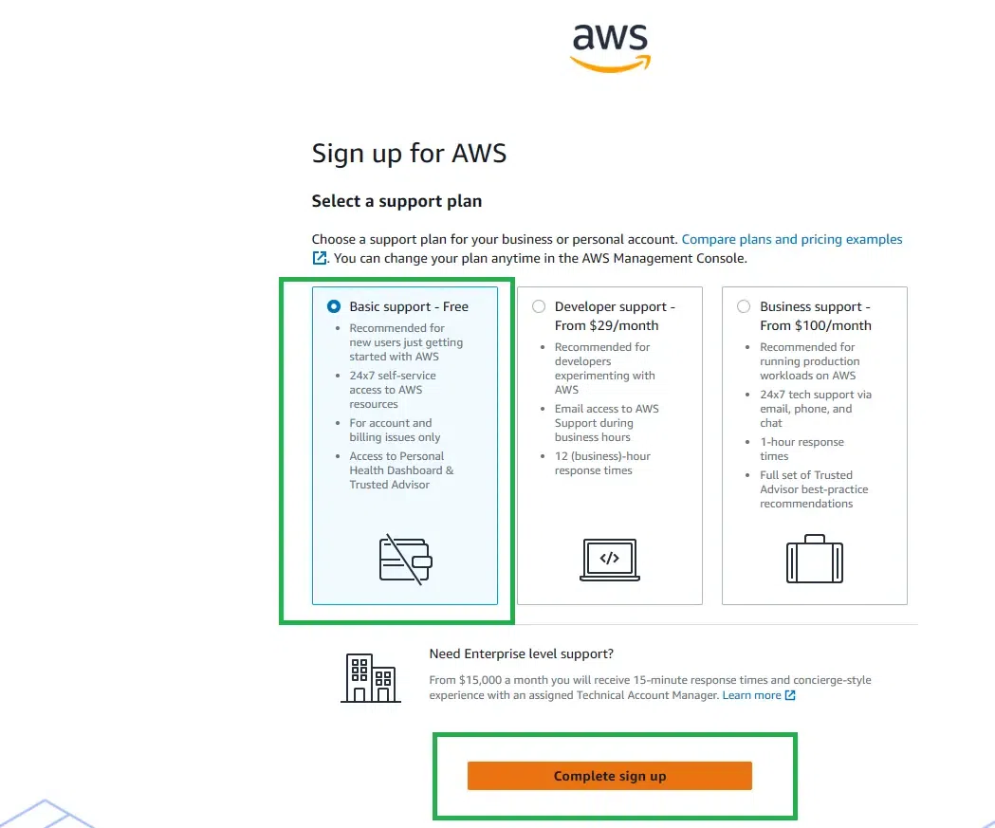

**Step 7: Account Confirmation**

* AWS account is successfully created and ready for use.

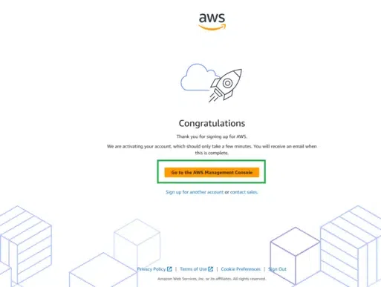

Launch an Ubuntu VM on AWS

**Steps to Create AWS Ubuntu Virtual Machine [EC2 Instance]**

**Step 1:** Open your AWS console and log in.

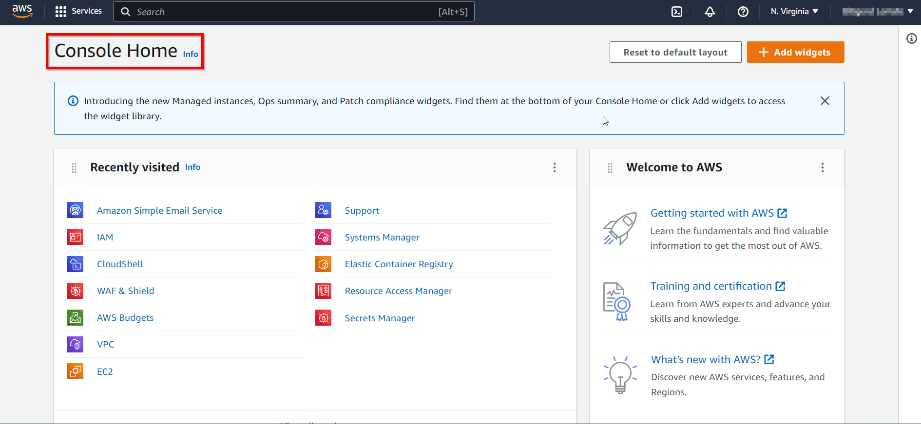**Step 2:** Search for EC2 in the search bar and click on it.

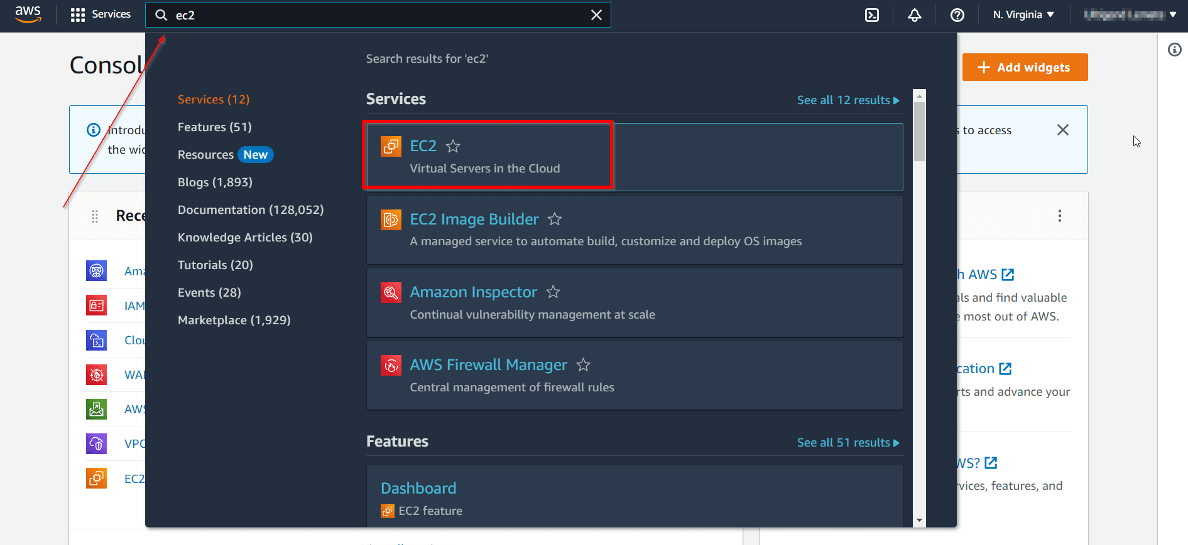**Step 3:** Once you are at the EC2 Dashboard, click on Launch to launch an instance.

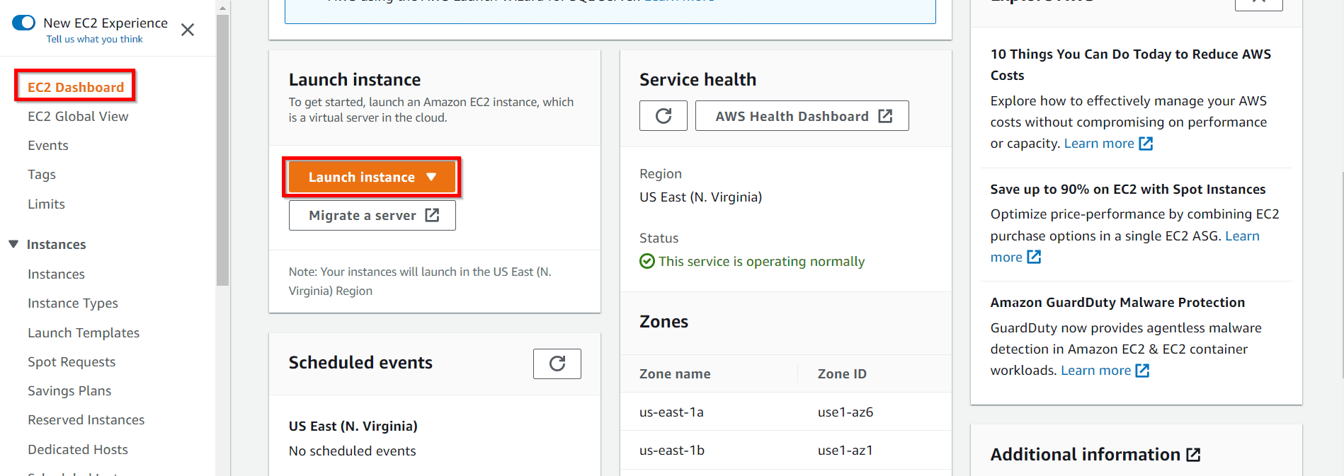**Step 4:** In the Name and Tags step you can add tags to an instance, here tags help you to enable categorizing AWS resources in different ways, for example, by owner, environment, or purpose.

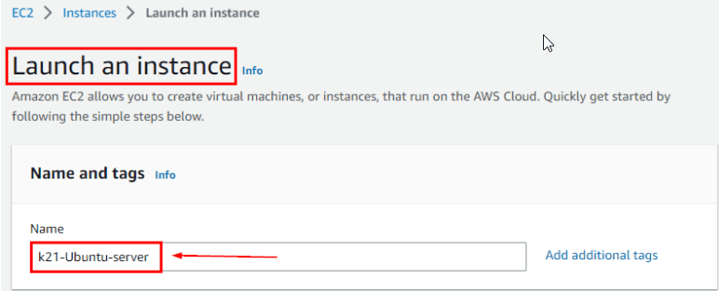

**Step 5:** Choose Ubuntu, select Ubuntu Server (HVM) architecture, and Click on Select.

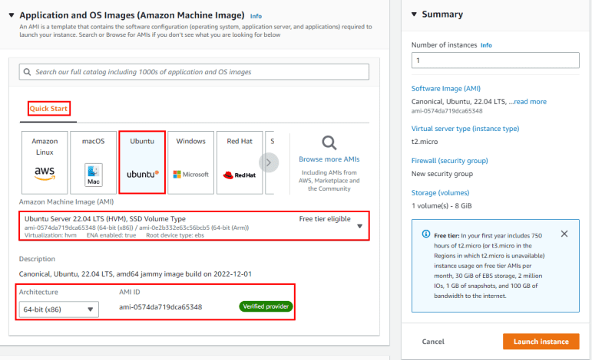

**Step 6:** For Select the t2.micro instance type, if you want you may select another instance type but they are chargeable so we choose the t2.micro instance type which is eligible for the free tier and limited resources.

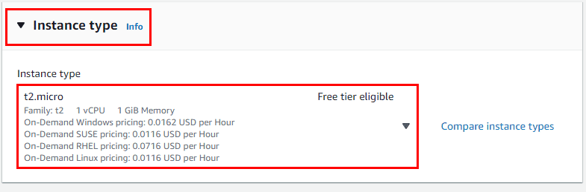**Note:** Here we must choose the instance type as t2.micro because it is free tier eligible. So, please make sure you select the t2.micro as the instance type else you shall be charged for running instances from Paid AMI.

**Step 7:** Select an existing key pair or create a new one, we will Create a new one, enter the name of the Key-pair as ubuntu-Key, select .ppk, and Create the Key Pair.

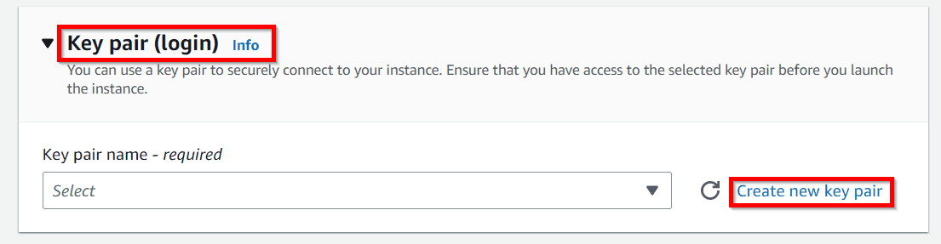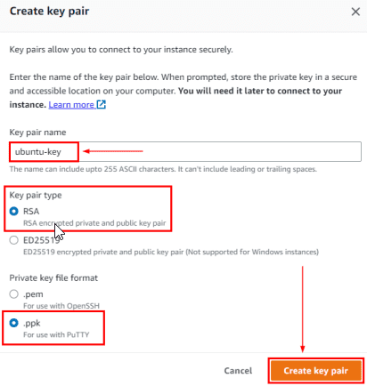

**Step 8:** Now review all the things you have Configured and Click on Launch Instance.

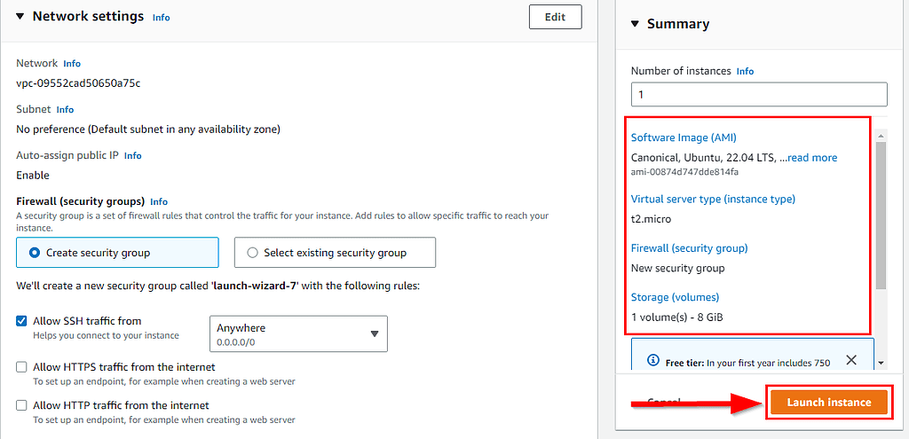**Step 9:** Now Click on View all Instances. Here, you shall see your instance is launching and the Status check is Initializing, wait for some time.

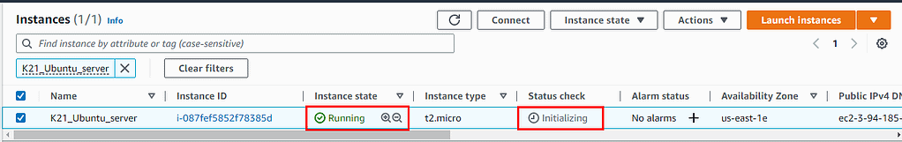**Step 10:**  Refresh and you shall see your instance are Up and Running, and the Status check has changed to 2/2 checks.

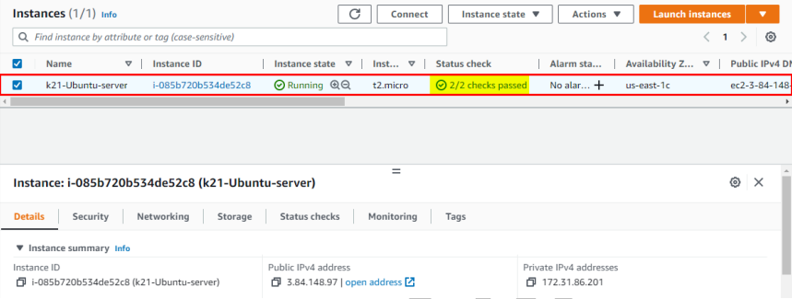

***Now, we have successfully created our Ubuntu EC2 Instance (VM) on AWS.***

***Note:****Now, wait for the Status check of the instance to change to 2/2 checks pass and then only proceed with further steps, and if the status check has not passed then you shall get an error in the further steps so please wait.*

**Connect To Ubuntu Virtual Machine**

**Step 11:**  Select your Instance and Click on Connect.

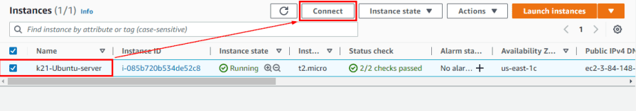**Step 12:** Select EC2 Instance Connect and Click on Connect.

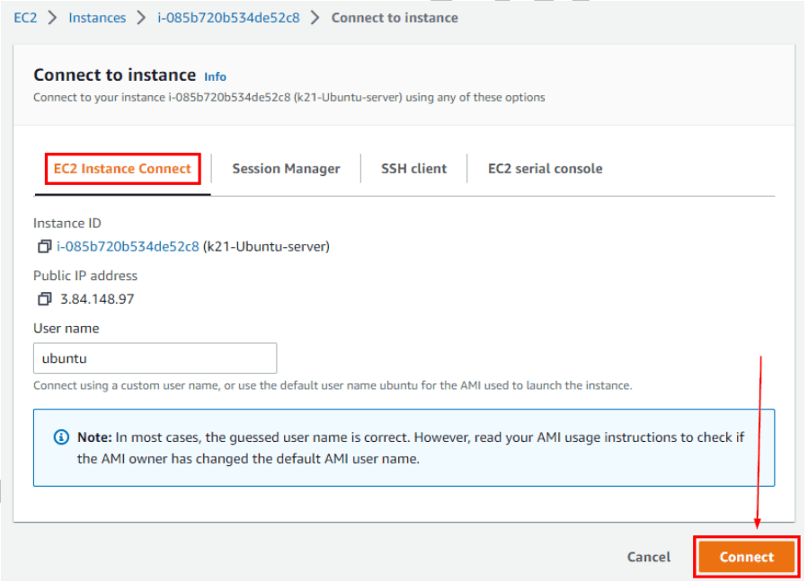

**Step 13:**  Now you shall be redirected to a new window and you shall see the Ubuntu CLI.

